Virtual Memory
We’ve seen that the purpose of cache is to increase the access to data by providing the illusion of a fast main memory.
- The purpose of virtual memory is to increase the available address space that processes can use by providing them with the illusion f a large, private main memory that is actually implemented on slower memory hardware that is shared by multiple processes (e.g. hard drive).
  - Provides the ability to run programs larger than main memory.
  - Hides differences in machine configuration from processes.
- The price to pay is that we have to do a translation on each memory reference.
  - This can slow down the system.
- Two approaches to virtual memory: segmentation and paging.
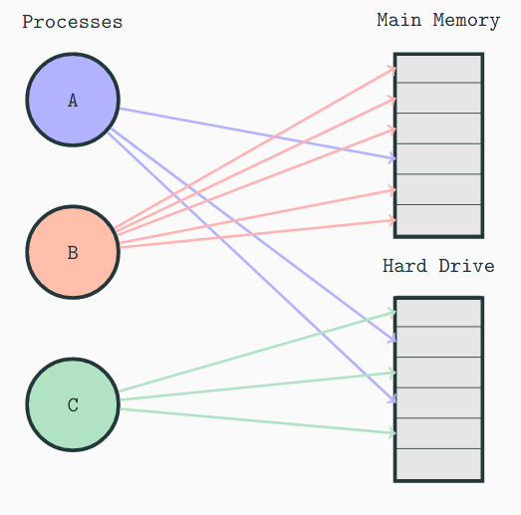
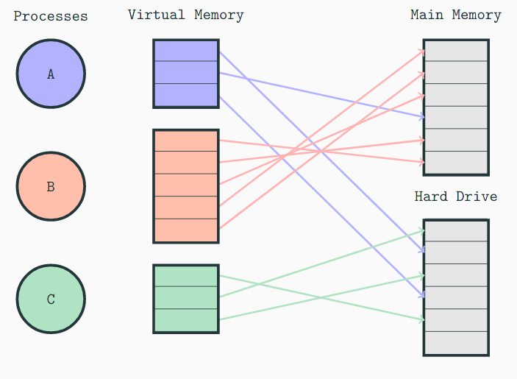

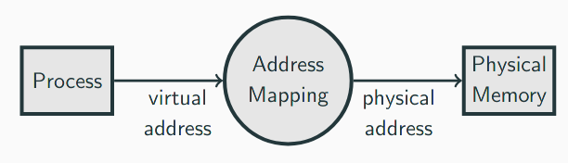

Processes are presented with their own virtual address space.
- e.g. Process 1 has its own virtual address 0, Process 2 has its own virtual address 0 too.
- Mutliple processes can use the same virtual address to refer to different physical memory locations.
An address mapping process translates a virtual address to a physical address.

Segmentation
Each process is allocated a contiguous segment of physical memory.
- A segment is located through its base, which contains the segment’s physical memory location and a bound that indicates the segment’s size.
  - Bound – Base = Size of Virtual Address Space.
  - Typically, systems do not allow processes to access addresses outside its bound.
- Base and Bound values are stored in dedicated registers.
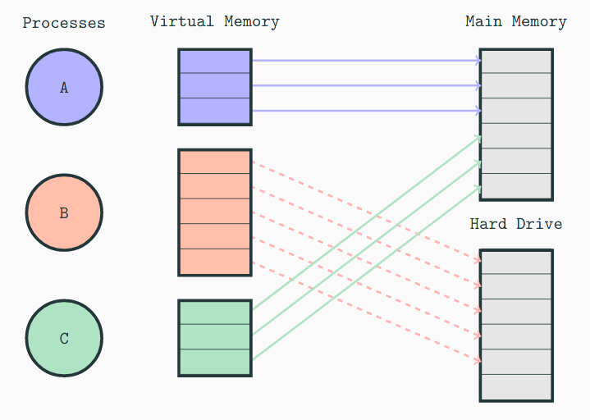

Each address is adjacent.
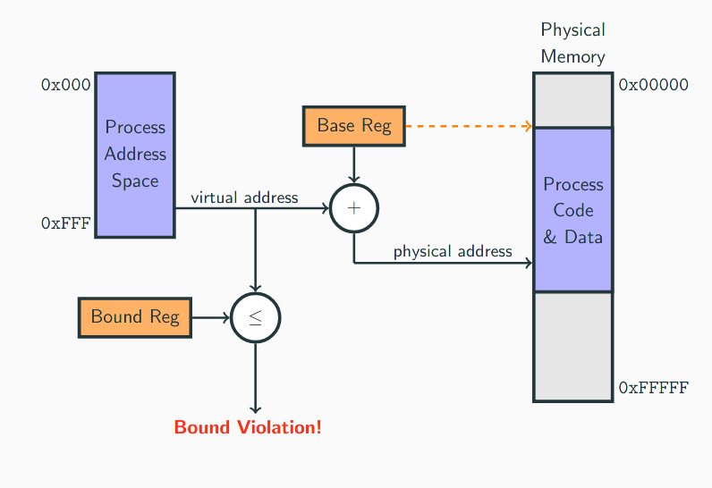

A danger of segmentation is external fragmentation.
- As processes start and end their code and data is swapped in and out of main memory.
- This swapping can lead to (external) fragmentation: small portions of memory are free, but not contiguous.
- This is a problem because segmentation requires processes to be stored in contiguous segments.
- Fragmentation can lead to situations in which overall there is sufficient free memory for a process to be swapped in, but it can’t be swapped in because the free memory is not contiguous.
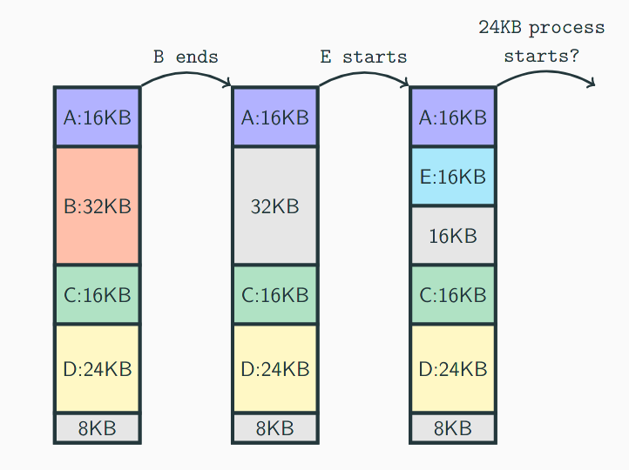

As fragmentation increases, it may become necessary for the memory to be defragmented.
- Defragmenting is a process that moves memory around so that free memory is in a continuous block.
  - Related to packing problem (computationally expensive to solve!)
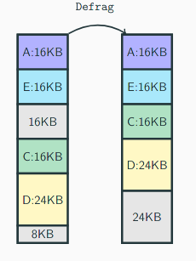

Paging
Main memory and virtual memory are divided into equal sized pages.
- Commonly not the same size as cache blocks.
- Pages in main memory are sometimes referred to as frames.
Pages are allocated to a particular process.
- They can be non-contiguous in memory.
- Interpret virtual addresses as a pair:
  - < virtual page number, offset >
- Each process has its own page table that maps virtual pages to physical pages.
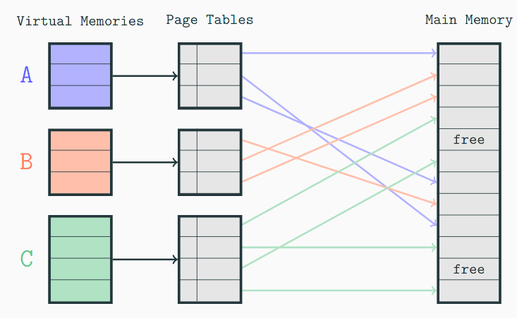

Virtual addresses are divided into two fields:
- Page field: indicates the virtual page location of the address
- Offset: indicates the location of the address within the page.
Physical addresses are divided into two fields:
- Page field: indicate the physical page location of the address.
- Offset: indicates the location of the address within the page.
The page table uses the virtual page field as an index to find the corresponding physical page field.
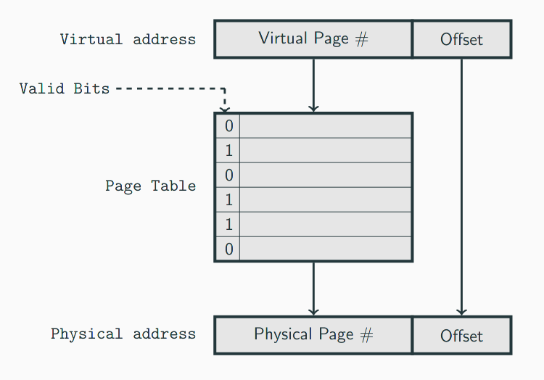

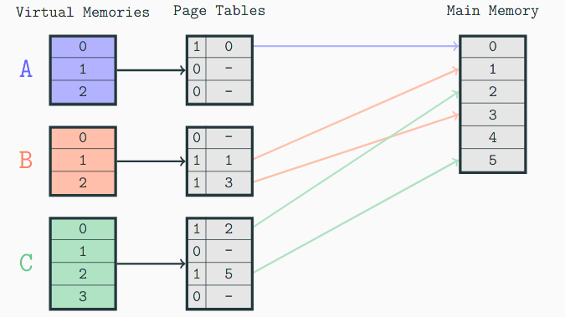
- The valid bit tells us whether the virtual page currently has a corresponding page in main memory.
- If a process requests a virtual page with a valid bit = 0, there is a page fault – the page has to be fetched from disk.

Suppose a system has a physical address of 2¹² addresses, and a process running on the system has a virtual address space of 2¹³ addresses, and the system uses byte addressing. Each physical page contains 2¹⁰ addresses.
- How many virtual pages are there?
  - Virtual page size and physical page size are the same, so:
2¹³ / 2¹⁰ = 2³ virtual pages.
  - Note: half as many physical pages, 2² physical pages.
- How many bits in a virtual address?
  - Page field: needs 2³ values → 3 bits.
  - Offset: needs 2¹⁰ values → 10 bits.
  - Total: 3 + 10 = 13 bits.
- How many bits in a physical address?
  - Page field: needs 2² values → 2 bits
  - Offset: needs 2¹⁰ values → 10 bits.
  - Total: 2 + 10 = 12 bits.
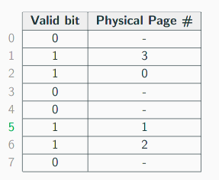
Suppose the page table belonging to the process is as follows. What happens when the process requests virtual address 1553₁₆?
- 1553₁₆ = 1010101010011₂
- Virtual page: 101₂ = 5₁₀
- Offset: 0101010011₂
5 is used to index the page table. Valid bit is 1, so physical page memory is extracted and concatenated with offset.
Physical address: 01 0101010011₂ = 553₁₆.

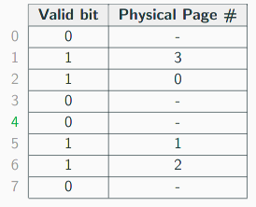
Suppose the page table belonging to the process is as follows. What happens when the process requests virtual address 1000000000100₂?
- Virtual page: 100₂ = 4₁₀.
- Offset: 000000000100₂.
4 is used to index into the page table. Valid bit is 0, so there is a page fault.
- The page is retrieved from slower storage (e.g. hard disk).
- Store newly retrieved page in main memory (remove victim page?), and update page table (set valid bit to 1, store physical page number)
Internal fragmentation occurs because when we allocate physical pages to process we cannot generally allocate the exact amount of memory required. This is because the granularity of pages means that we may have to over allocate memory, leading to unusable free memory.
- Consider a process that needs 18KB of memory, in a system with a page size of 12KB.
  - We must allocate the process 2x12KB = 24KB worth of memory.
  - 6KB of the second page is not used by the process, but cannot be allocated to other processes.
Paging cannot suffer from external fragmentation: processes do not have to be stored contiguously.
Segmentation cannot suffer from internal fragmentation: processes can be allocated the exact amount of memory that they require.
- Systems can use a mix of paging and segmentation in an attempt to get the best of both worlds.
  - Virtual addresses are divided into segments of variable length.
  - Segments and main memory are divided into fixed-size pages.
  - Each segment has its own page table, so every process has multiple page tables.

Page tables
Where are page tables stored?
- In main memory.
- Every time we want to access a main memory address we would have to access main memory twice:
  - Once to access the page table to convert virtual to physical address.
  - Once to access the physical address.
What is the effective access time using paging?
- There is a penalty when using virtual paging: there must be two main memory accesses, one for the page table, one for the actual data.
Suppose a main memory access requires 200ns, and the page fault rate is 1% (99% of the time we find the page we want in main memory).
Assume it costs us 10ms to access a page not in main memory (fetching the page from slower storage, updating page table, accessing data).
- The effective access time would be:
- EAT = 0.99 x (200ns + 200ns) + 0.01 * (10ms) = 100,396ns (double!)

An option is to store the most recent page table lookups (virtual and physical address pairs) in a special cache, called the translation lookaside buffer (TLB).
- Use of a TLB reduces the access to main memory, and speeds up address translation.
The steps for using a TLB:
- Extract the virtual page number from the virtual address
- Extract the offset from the virtual address
- Look up the virtual page number in the TLB
- If there is a TLB hit, use the corresponding physical page number, add the offset to the physical page number to get memory location
- If there is a TLB miss, go to the page table to get the necessary frame number. If the page is in memory, use the corresponding frame number and add the offset to yield the hpysical address.
- If the page is not in main memory, generate a page fault and restart the access when the page fault is complete.
